**What we know:**

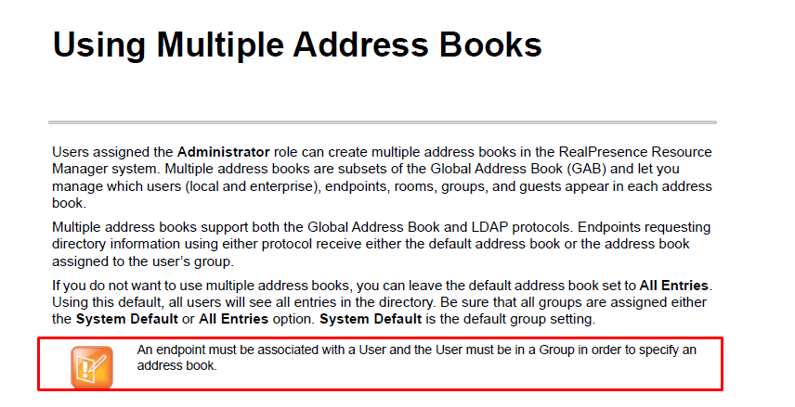

**What we have:**

4 endpoints, each of them is associated with a RPRM local user.

HDX – 10.253.91.85, associated with the RPRM local user MisterHDX; Not a dynamically provisioned endpoint, using Polycom GDS protocol:

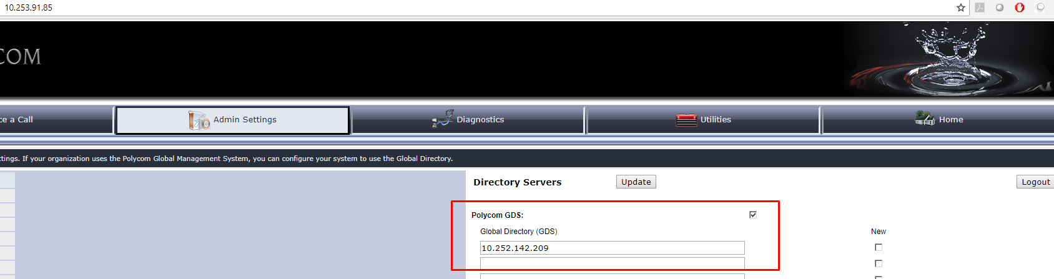

GS A – 10.253.91.25, associated with the RPRM local user Mister25; Dynamically provisioned endpoint (in fact RPRM Guide says that Group Series units have to be dynamically provisioned); hence it is using LDAP Address Book protocol:

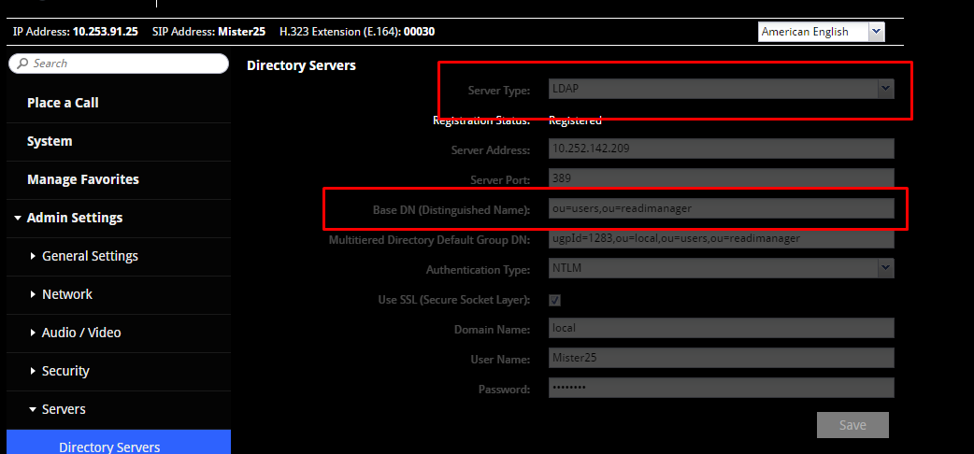

RPD A user: 10.252.142.221, dynamically provisioned endpoint using RPRM local user desktop1; hence it is using LDAP address book protocol as well

RPD B user: 10.252.142.221, dynamically provisioned endpoint using RPRM local user desktop2; hence it is using LDAP address book protocol as well

**What we are trying to achieve:**

We want to have separate address book for RPD A and GS A and RPD B and HDX. So RPD A and GS A will be seeing each other but not RPD B and HDX and vice versa.

All provisioned endpoints are associated with the users already as users were used to provision them. For non-dynamically provisioned HDX I have associated it with the user MisterHDX manually:

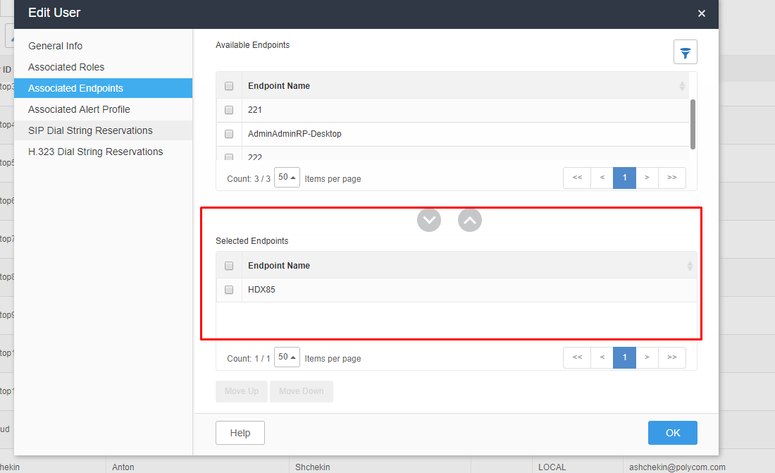

FYI – RPRM doesn’t list non-dynamically managed Group Series endpoint in the list of available endpoints. Again, this is because Group Series should be dynamically provisioned as per RPRM Operations Guide.

So now I create 2 address books:

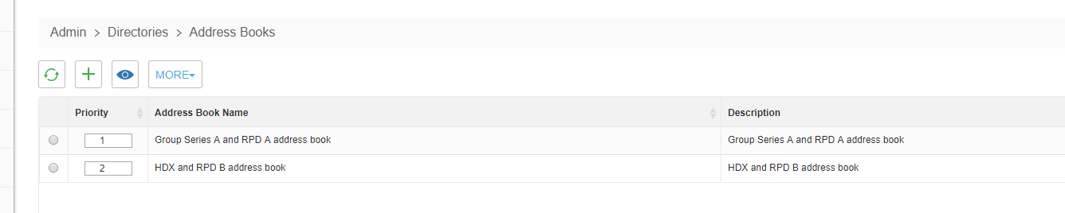

I also create 2 User Groups:

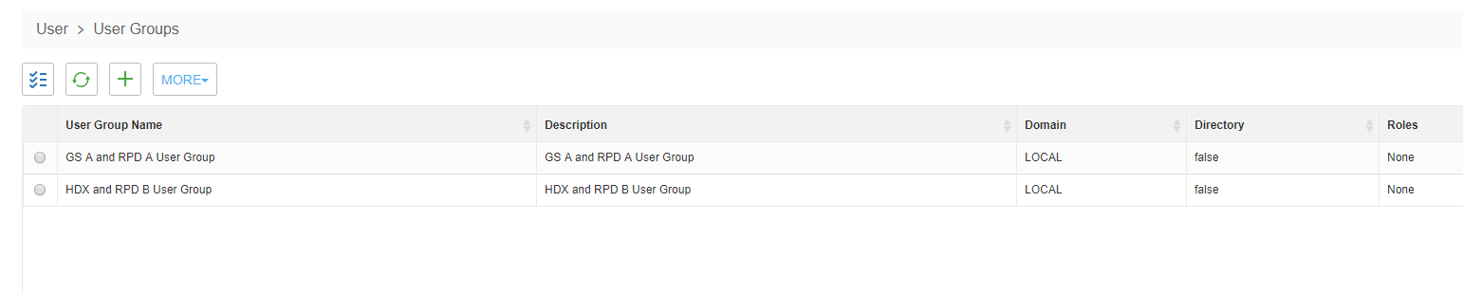

Each of the address books is associated with corresponding User Group:

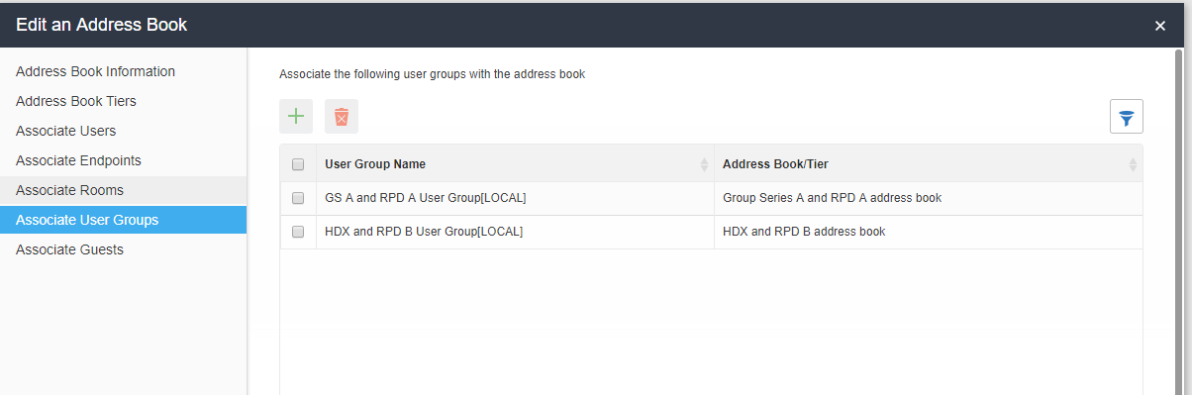

User group “GS A and RPD A User Group” has Mister25 (associated with GSA) and desktop1 (associated with RPDA) as members:

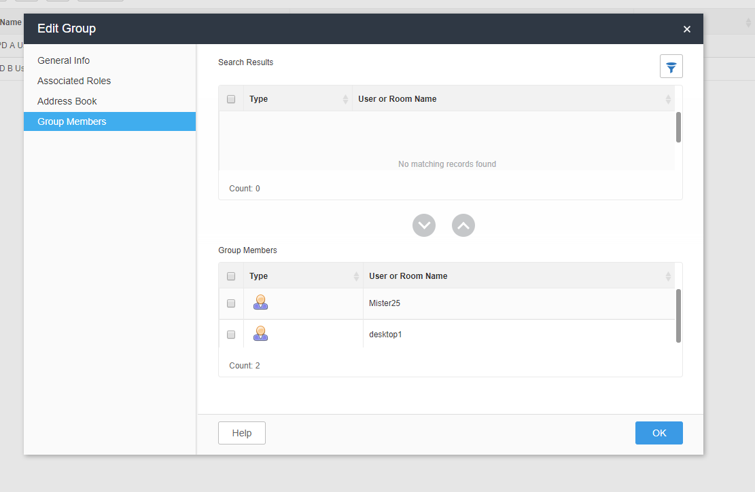

User group “HDX and RPD B User Group” has desktop2 (associated with RPD B) and MisterHDX (associated with HDX) as members:

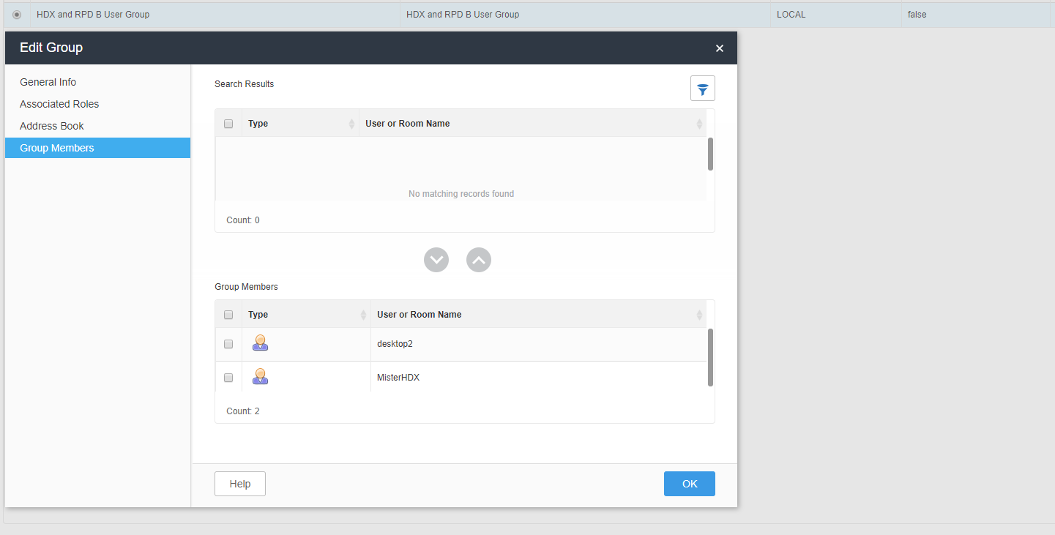

Such configuration allows to achieve what we are trying to achieve.